|  |  |  |
| --- | --- | --- |
|  | **GİRİŞ** | **ÇIKIŞ** |
| **1. DERS** | **7.30** | **8.10** |
| **2. DERS** | **8.20** | **9.00** |
| **3. DERS** | **9.10** | **9.50** |
| **4. DERS** | **9.55** | **10.35** |
| **5. DERS** | **10.40** | **11.20** |
| **6. DERS** | **11.25** | **12.05** |
| **7. DERS** | **12.10** | **12.50** |

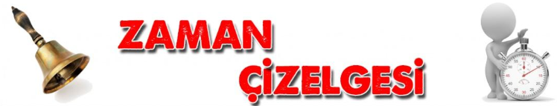

**2024-2025 EĞİTİM-ÖĞRETİM YILI MEHMET AKİF ORTAOKULU**

**ZAMAN ÇİZELGESİ**